SYSTEM CONTEXT &
COMPONENT MAP
UE5 Data-Driven Game
Normative architecture specification

Attribute | Value
Status | Approved decisions consolidated for implementation
Version | 1.0
Date | 6 August 2026
Base documents | Architecture v2 (2.1); Glossary & Naming Convention (1.0)
Scope | Runtime, authoring/build tools, ownership, lifetime and dependency boundaries
Normativity | All component boundaries and internal components in this document are normative

Core rule. Lua owns canonical gameplay-state and gameplay consequences. Unreal Engine owns presentation, resources and platform integration. C++ owns the typed infrastructure boundary and orchestration.

Document Map
Section | Purpose
1. Purpose and Authority | Scope, normative force and explicit exclusions.
2. System Context | System boundary, actors and external dependencies.
3. Runtime Topology | Five C++ modules and allowed dependencies.
4. Lifetime and Ownership | Application, session, world, presentation, route and operation scopes.
5–9. Module Maps | Concrete C++ classes and Lua logical components.
10. Authoring and Build Tools | Development-only components inside the system boundary.
11. Component Register | Responsibility, owner, lifetime and dependencies.
12. Runtime Flows | Bootstrap, command, travel, resources, save/load and repository build.
13. Dependency and Interaction Rules | Allowed and forbidden coupling.
14. Failure and Recovery | Failure domains and controlled recovery.
15. v1 / Future Boundary | Capabilities intentionally deferred.
16. Conformance Checklist | Review criteria for implementation.

This document uses the canonical terms and naming rules from Glossary & Naming Convention. Where Architecture v2 used “gameplay action”, this document applies the later normative distinction: UI action and gameplay command.

1. Purpose and Authority
This specification defines the system boundary, concrete runtime modules, component ownership, lifetime scopes, legal dependency directions and principal data flows. It is the implementation map for the first production skeleton.

1.1 Normative force
- The five runtime modules, named components, ownership assignments and dependency directions are mandatory for v1.
- Concrete C++ classes and Lua components listed here are normative. Renaming or moving a responsibility requires an architecture review and document update.
- Internal algorithms, function signatures, JSON schemas and exact directory layout remain subjects of later contract documents.

1.2 Explicit exclusions
- Multiplayer, replication, dedicated server and lockstep simulation.
- Security sandbox for untrusted Lua code or mods.
- Event sourcing, universal rollback and general transaction infrastructure.
- Arbitrary UObject or Blueprint reflection exposed to Lua.
- Partial UI patch protocol; v1 applies complete presentation snapshots and discrete effects.
- Full runtime hot reload without recreating the affected session.

2. System Context
The project boundary includes both the shipped runtime and the authoring/build toolchain that validates, indexes and packages core content and mods. Operating-system services, storage media and package providers remain external dependencies.
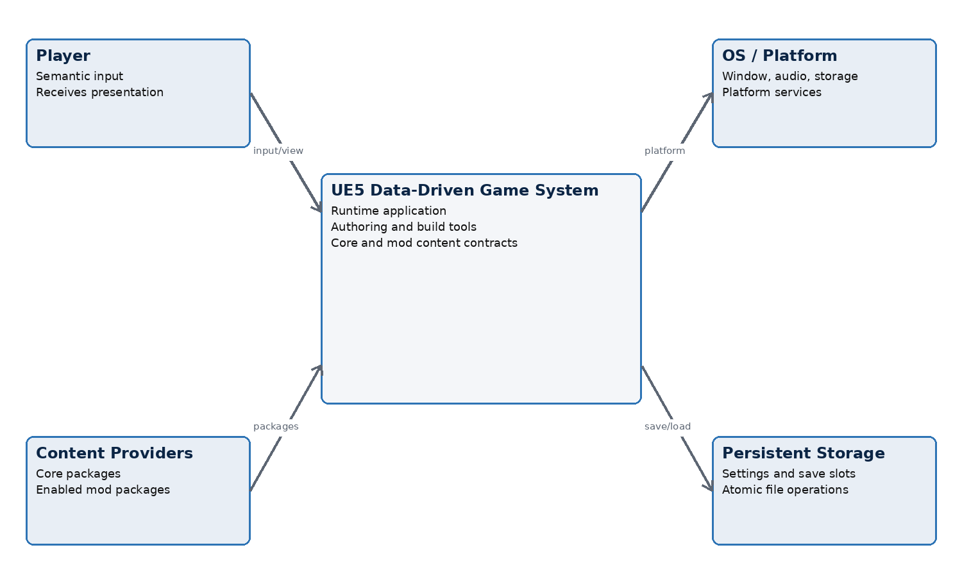
Figure 1 — C4-style system context

2.1 Context actors and systems
Actor / system | Relationship to the game system
Player | Provides semantic input and receives visual, audio and world presentation.
Content author | Creates core definitions, Lua modules, localization and presentation resources through authoring tools.
Mod author | Creates a package with a unique mod_id, its own new IDs and permitted full overrides of existing IDs.
OS / platform | Provides process, window, input devices, audio, locale, clocks and platform-specific integration.
Persistent storage | Stores settings, enabled-mod order, save slots, diagnostics and packaged content.
Unreal Engine toolchain | Compiles C++, cooks assets and packages the application; invoked by system-owned build integration.

2.2 Trust and identity boundary
- Core and enabled mod Lua code are trusted code in v1; the runtime does not claim isolation from malicious code.
- A mod may override an existing core:* definition but may not create a new core:* ID.
- Logical IDs and schema-defined values cross subsystem boundaries; physical asset paths remain behind resource definitions and adapters.

3. Runtime Topology
Runtime C++ code is divided into exactly five project modules. Development-only tool modules do not count as runtime modules and must never become runtime dependencies.
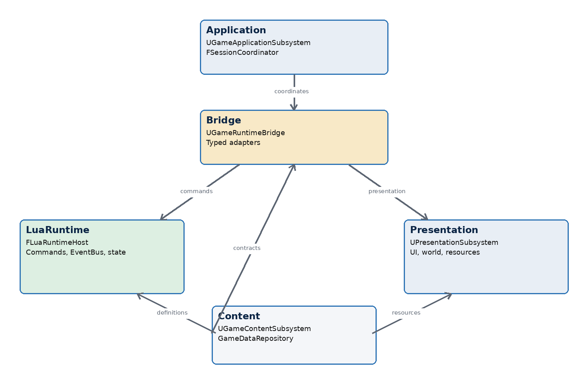
Figure 2 — Runtime module topology and primary dependency roles
Module | Primary responsibility | May depend on
Application | Process mode, session lifecycle, operation coordination and top-level error state. | Content, LuaRuntime, Bridge, Presentation
Content | Package discovery/resolution, repository build, validation and immutable resolved data. | Engine/Core only; no other project runtime module
LuaRuntime | Lua VM, canonical gameplay-state, commands, EventBus, runtime instances and UI projection. | Content
Presentation | UI, world projection, resources, localization, audio/animation and semantic input capture. | Content
Bridge | Typed Lua ↔ UE façade and adapters; save codec/storage boundary. | Content, LuaRuntime, Presentation

Dependency rule. Application is the composition root. Bridge mediates runtime interaction. Content is the lowest project module. LuaRuntime and Presentation never depend on each other directly.

3.1 Forbidden module edges
- Content → Application, LuaRuntime, Bridge or Presentation.
- LuaRuntime → Application, Bridge or Presentation.
- Presentation → Application, Bridge or LuaRuntime.
- Any runtime module → development-only authoring/build module.
- Blueprint assets → direct Lua invocation or canonical gameplay-state access.

4. Lifetime and Ownership Model
Scope | Created / destroyed by | Owns | Invariant
Application | Unreal GameInstance / process | Application subsystem, settings, global diagnostics | Exists from application bootstrap to shutdown.
Game Session | FSessionCoordinator | Lua VM, repository snapshot reference, gameplay-state, session bridge | At most one active session per process.
World | Unreal world lifecycle observed by Presentation | Persistent presentation world and Actor projections | Not authoritative for gameplay-state.
Presentation | UPresentationSubsystem for the active mode/session | Game Shell, presenters, streaming pins and desired view | Rebuildable from a presentation snapshot.
Route / UI instance | FRouteLayerManager | One screen/route lifecycle and stale-input revision | Late input is rejected by instance ID/revision.
Operation | Owning service/coordinator | Asset request, repository build, save/load or transition handle | Completion becomes an explicit technical event.

4.1 Application modes and Lua VM lifecycle
Transition | Required behavior
Application startup | Application creates infrastructure, resolves content and immediately creates a lightweight menu Lua session.
Main menu → new/load game | Destroy the menu session, select a repository snapshot, then create one full Game Session with one Lua VM.
Game → main menu | Block new gameplay input, flush/abort operations, destroy the full Game Session, then create a new lightweight menu Lua session.
Restart game session | Destroy and recreate session-scoped components without restarting the process.
Application shutdown | Stop input, release session, presentation and operations, then release application services.

Single-session invariant. Only one Game Session is active in a process. A menu session and a gameplay session never coexist.

4.2 Ownership principles
- FSessionCoordinator is the sole creator and destroyer of session-scoped components.
- The active GameDataRepository snapshot is immutable and shared by reference for the session lifetime.
- UE presentation objects may disappear and be rebuilt without changing canonical gameplay-state.
- Operation callbacks must be invalidated or ignored when their owner scope ends.

5. Application Module
Application is the composition root and owns process-level mode changes. It coordinates services but contains no gameplay rules, repository merge logic or presentation rendering logic.
Concrete component | Responsibility | Lifetime
UGameApplicationSubsystem | GameInstanceSubsystem entry point; owns application state and service composition. | Application
FSessionCoordinator | Creates/destroys menu and gameplay sessions in strict order; enforces single-session invariant. | Application
FApplicationModeController | Transitions Boot, Menu, StartingSession, InGame, ReturningToMenu, Failed and Shutdown. | Application
FOperationCoordinator | Tracks top-level repository, session, save/load and shutdown operations and cancellation tokens. | Application
FApplicationErrorRouter | Normalizes fatal startup/session errors and selects recovery surface. | Application
FSessionContext | Immutable composition record for one session: mode, repository, runtime host, bridge and presentation handle. | Game Session

5.1 Session creation contract
1. Acquire a validated immutable GameDataRepository snapshot.
2. Create the Presentation session context in a non-interactive state.
3. Create FLuaRuntimeHost and its logical components on the Game Thread.
4. Create UGameRuntimeBridge and bind only typed adapters allowed for the selected session mode.
5. Bootstrap core and enabled mod Lua modules in deterministic order.
6. For load, restore the validated save data tree before first gameplay projection.
7. Apply the initial presentation snapshot; enable semantic input only after successful reconciliation.

6. Content Module
Content converts core and enabled mod packages into one all-or-nothing, read-only GameDataRepository snapshot. The content pipeline is deterministic for the same packages, versions and enabled-mod order.
FPackageDiscoveryService
→ FContentPackageResolver
→ FRepositoryBuilder
→ FRepositoryValidator
→ UGameDataRepository (immutable snapshot)
Concrete component | Responsibility
UGameContentSubsystem | Application-facing service for discovery, build, cache and active snapshot publication.
FPackageDiscoveryService | Discovers core and candidate mod manifests without applying hidden ordering.
FContentPackageResolver | Validates mod_id uniqueness, dependencies and exact user enabled-mod order.
FRepositoryBuilder | Loads JSON5, normalizes records, applies last-provider-wins full override by ID and builds indices.
FRepositoryValidator | Validates envelopes, schemas, references, namespaces, localization/resource links and provenance.
FLocalizationSnapshotBuilder | Builds the resolved text catalog consumed by the Localization Adapter.
FResourceManifestBuilder | Builds resource_id → presentation definition records without loading UE assets.
UGameDataRepository | Read-only definitions, schemas, provenance, redirects, indices and repository fingerprint.

6.1 Publication rule
Atomic publication. A build publishes exactly one complete validated snapshot or no snapshot. A partially resolved repository is never visible to LuaRuntime, Bridge or Presentation.

7. LuaRuntime Module
LuaRuntime embeds one Lua VM per session, always on the Game Thread. Its C++ host enforces phase boundaries, value conversion, limits and diagnostics; gameplay behavior remains in registered Lua modules.

7.1 C++ host classes
Concrete class | Responsibility
FLuaRuntimeHost | Owns VM creation, bootstrap, calls, shutdown, failure state and Game Thread assertion.
FLuaValueMarshaller | Converts only approved value trees and schema-defined records; rejects UObject and arbitrary userdata.
FLuaExecutionGuard | Applies re-entry rules, instruction/time budgets where configured and diagnostic context.
FLuaModuleLoader | Loads core then mods in resolved order and exposes only registered bridge capabilities.
FLuaRuntimeDiagnostics | Attaches module, command/event ID, provenance and phase to failures.

7.2 Normative Lua logical components
Lua component | Owned responsibility | Must not own
Module Lifecycle Manager | Module registration, init/start/stop order and hook ownership. | UE object lifecycle or package discovery
Action Registry | Public UI action contracts and mapping from action_id to command_id. | Gameplay mutation
Command Dispatcher | Queue, schema validation, preconditions, before phase, handler invocation and structured result. | Presentation implementation
EventBus | Both cancellable before_* delivery and post-mutation gameplay fact delivery with deterministic order. | Direct UE callbacks
Canonical Game State | Single serializable gameplay-state root. | Functions, userdata, UObject, cycles or direct definition tables
Runtime Instance Registry | Rebuildable runtime objects keyed by stable instance_id. | Authoritative static definitions
Gameplay Service Registry | Registered domain APIs allowed to mutate state under dispatcher phase rules. | File I/O or UE asset access
Command Queue / Event Queue | FIFO, non-recursive breadth-first processing and pump limits. | Persistence across save/load
UI Projection Controller | Resolved UI-document, presentation snapshots/effects and stale projection revision. | UMG Widget instances

7.3 Command and EventBus rules
- The same EventBus implementation serves two distinct phases: cancellable before_* events and non-cancellable gameplay facts.
- A before handler may allow or reject the command only. It may not mutate canonical state or replace command payload.
- Only Command Handlers and explicitly registered Gameplay Services may mutate canonical state.
- An event handler requests mutation through those APIs or queues a new command; it does not mutate state directly.
- A successful command completes mutation before any gameplay fact is delivered. A failed or cancelled command emits no gameplay facts.

8. Bridge Module
Bridge is the only runtime integration surface between LuaRuntime and Unreal-facing services. Lua sees one registered façade; adapters behind it remain replaceable and testable.
Concrete class | Responsibility
UGameRuntimeBridge | Session-scoped façade; registers value-only APIs and routes calls to typed adapters.
FUIBridgeAdapter | Transfers resolved UI-documents, snapshots, effects and semantic inputs.
FWorldBridgeAdapter | Applies logical world presentation requests to the persistent presentation world.
FResourceBridgeAdapter | Resolves and prepares resource_id requests and reports explicit technical results.
FAudioAnimationBridgeAdapter | Maps semantic music, sound and animation intents to Presentation services.
FSaveBridgeAdapter | Requests a clean Lua save tree, validates allowed types, invokes codec/storage and restores a decoded tree.
FPlatformBridgeAdapter | Exposes narrow locale, settings and platform capability records where gameplay requires them.
FBridgeRequestRegistry | Owns opaque operation handles, scope cancellation and late-completion rejection.

8.1 Boundary data
Allowed | Forbidden
Canonical logical IDs; finite numbers; strings; booleans; arrays; maps; schema-defined records; opaque operation handles. | UObject/AActor/UWorld/Widget references; arbitrary reflection; function pointers; Lua tables with cycles/metatables; physical asset paths in gameplay data.

8.2 Technical completion rule
Worker, streaming, save and platform completions never enter Lua re-entrantly. Bridge records a technical event and delivers it at the next safe runtime phase after validating session and operation ownership.

9. Presentation Module
Presentation owns the rebuildable visual and audio projection. It may maintain presentation-state for local UX, but that state never decides gameplay consequences.
Concrete component | Responsibility
UPresentationSubsystem | World/application-facing owner of presentation services and session binding.
FPresentationCoordinator | Applies snapshots and effects; coordinates UI, world, character, audio and resource services.
FSnapshotReconciler | Compares desired presentation snapshot with current projection and produces deterministic apply operations.
FUIDocumentRenderer | Validates and instantiates UI components from a Resolved UI-document.
UGameShellWidget | Persistent root Widget with named background, location, character, core UI, overlay and modal slots.
FRouteLayerManager | Owns route, overlay and modal stacks plus ui_instance_id/route_instance_id revisions.
UWidgetRegistry | Maps widget_id to approved C++/UMG factories and property contracts.
FSemanticInputAdapter | Converts control interaction to action_id plus minimal schema-defined arguments.
FPortraitPresenter | Presents 2D portraits and semantic portrait animations.
FCharacter3DPresenter | Presents 3D characters, appearance and semantic animations.
FWorldPresentationAdapter | Maintains one persistent presentation world and activates/streams scene content by presentation_id.
FResourceResolver | Maps resource_id to Unreal Soft Object Paths from resolved presentation definitions.
UAssetStreamingService | Prepare, prefetch, pin, release and eviction; reports explicit operation results.
FLocalizationAdapter | Resolves TextSpec/text_id and arguments into FText using the localization snapshot.
FAudioPresentationService | Applies music, ambience and sound snapshots/effects.

9.1 C++ / Blueprint / UMG boundary
- C++ owns lifecycle, validation, reconciliation, registries, stale-input protection and bridge integration.
- Blueprint/UMG owns composition, styles, animation, binding to presentation models and local visual reactions of controls.
- Blueprint does not call Lua functions by name, dispatch gameplay commands directly or retain authoritative gameplay-state.
- Portrait and 3D character presentation are separate presenters under one coordinator.
- v1 uses one persistent UWorld; internal level streaming is an implementation detail hidden from Lua.

10. Authoring and Build Tools
Authoring and build tools are inside the designed system boundary but are development-only deliverables. They consume the same schemas and validators as runtime wherever practical, while never becoming runtime dependencies.
Tool component | Responsibility | Output
Content Schema Compiler | Compiles authoritative definition/UI schemas and generated validation metadata. | Versioned schema bundle
Package Authoring CLI | Creates and validates core/mod manifests, namespaces, dependencies and package layout. | Content package source
Repository Linter | Runs full build/override/reference/provenance validation outside the game. | Diagnostics and fingerprint
Localization Validator | Checks text_id coverage, arguments, rich-text roles and locale fallback. | Validated localization bundle
Resource Catalog Builder | Validates resource_id records and Unreal asset references. | Resolved resource catalog
Mod Packager | Produces deterministic distributable mod packages and manifest metadata. | Versioned mod package
Cook/Package Integration | Ensures referenced presentation assets are staged and runtime manifests are embedded. | Shippable application/content
Contract Test Harness | Executes repository, Lua command/event, bridge and UI-document fixtures headlessly. | Test and compatibility report

10.1 Shared-contract rule
No validator fork. Runtime and tooling may have different entry points, but canonical ID, schema, override and reference rules must come from the same contract source or generated artifact.

11. Consolidated Component Register
The following register is the minimum implementation set. “Owner” identifies the component that controls creation and destruction; it does not imply permission to modify canonical gameplay-state.
Component | Owner | Lifetime | Direct project dependencies
UGameApplicationSubsystem | GameInstance | Application | Content, LuaRuntime, Bridge, Presentation
FSessionCoordinator | UGameApplicationSubsystem | Application | All runtime module public façades
UGameContentSubsystem | GameInstance | Application | None
UGameDataRepository | UGameContentSubsystem | Snapshot / Session ref | None
FLuaRuntimeHost | FSessionCoordinator | Game Session | Content
Command Dispatcher | FLuaRuntimeHost | Game Session | EventBus, state, services
EventBus | FLuaRuntimeHost | Game Session | Module registry, queues
Canonical Game State | FLuaRuntimeHost | Game Session | Repository IDs only
UI Projection Controller | FLuaRuntimeHost | Game Session | State, repository
UGameRuntimeBridge | FSessionCoordinator | Game Session | LuaRuntime, Presentation, Content
FBridgeRequestRegistry | UGameRuntimeBridge | Game Session / Operation | Typed adapters
UPresentationSubsystem | GameInstance / World | Application | Content
FPresentationCoordinator | UPresentationSubsystem | Presentation | Presentation services
UGameShellWidget | FPresentationCoordinator | Presentation | Widget Registry
FRouteLayerManager | FPresentationCoordinator | Presentation / Route | UI renderer, Game Shell
UAssetStreamingService | UPresentationSubsystem | Application / Operation | Resource Resolver
FWorldPresentationAdapter | UPresentationSubsystem | World | Streaming service
FSaveBridgeAdapter | UGameRuntimeBridge | Game Session / Operation | Lua value marshaller, platform storage

12. Principal Runtime Flows

12.1 Semantic input → gameplay command → presentation
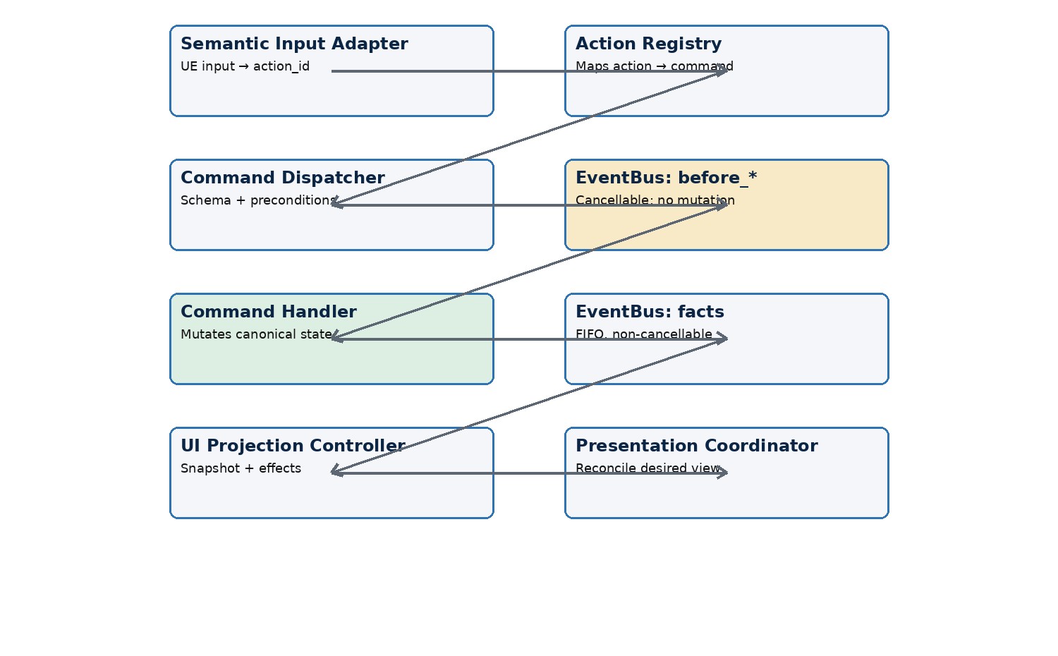
Figure 3 — Normative command and presentation flow
Cancellation returns a structured command result through the UI action contract. It does not mutate canonical gameplay-state, publish a gameplay fact or apply a speculative presentation snapshot.

12.2 Repository build
1. Discover core and candidate packages; parse manifests.
2. Resolve the exact enabled-mod list and order; reject duplicate mod_id.
3. Load JSON5 and localization/resource records in deterministic package/file order.
4. Normalize and validate canonical IDs; reject a mod that creates a new core:* ID.
5. Apply full replacement by ID; retain winner and provenance.
6. Validate schemas, references, localization, resources and redirects.
7. Build indices, localization snapshot, resource manifest and repository fingerprint.
8. Atomically publish the immutable GameDataRepository snapshot.

12.3 Location transition
1. UI control emits action_id core:location.travel with target_location_id.
2. Action Registry maps the action to the matching gameplay command contract.
3. Command Dispatcher validates payload and current preconditions.
4. EventBus delivers core:location.before_leave and core:location.before_enter as cancellable phases; handlers may reject only.
5. Command Handler mutates current location and related canonical state through registered services.
6. EventBus publishes neutral facts such as core:location.leave and core:location.enter in deterministic FIFO order.
7. UI Projection Controller emits the new presentation snapshot, optional transition effect and prefetch hints.
8. Presentation reconciles the persistent world, location screen, portraits/3D characters, audio and available actions.

12.4 Save
1. Application starts a save operation and temporarily records its session identity.
2. FSaveBridgeAdapter asks LuaRuntime for an explicit clean save data tree.
3. Lua validates gameplay invariants and exports only schema-declared state values.
4. C++ FLuaValueMarshaller validates types, finiteness, depth, cycles and schema compatibility.
5. C++ Save Codec serializes the tree with game/save schema versions, enabled mods and repository fingerprint metadata.
6. Platform storage performs an atomic slot write and reports a technical event.
7. Bridge delivers completion at a safe runtime phase if the session/operation is still current.

12.5 Load
1. C++ reads and decodes the slot, validates envelope and permitted value types.
2. Content resolves the required enabled-mod set and builds a compatible repository snapshot.
3. Application creates a fresh gameplay session and one fresh Lua VM.
4. Lua receives the decoded clean tree, runs save migrations and validates canonical invariants.
5. Runtime Instance Registry rebuilds runtime objects from type_id, definition_id, instance_id and instance state.
6. Lua produces the initial complete presentation snapshot; UE rebuilds presentation-state.
Save boundary. Lua defines and exports the canonical save tree. C++ validates its allowed types, serializes/deserializes it, manages slots and performs platform file I/O.

12.6 Resource prepare and prefetch
- Lua emits resource_id and optional prefetch hints, never a Soft Object Path.
- Resource Resolver maps resource_id through the resolved presentation definition.
- Asset Streaming Service creates an operation, loads asynchronously, pins according to scope and reports success/failure as a technical event.
- Prefetch does not make a gameplay transition legal and does not guarantee indefinite retention.

13. Dependency and Interaction Rules
Rule | Required consequence
One canonical gameplay-state | No parallel C++/Blueprint domain model may become authoritative.
One Lua EventBus | C++ and Blueprint may use technical delegates internally but do not expose a second gameplay event system.
No direct Lua ↔ Presentation dependency | All interaction passes through the typed Bridge façade.
Definitions are immutable | Runtime state stores logical IDs, not mutable definition copies or UE references.
No synchronous re-entry | Callbacks and worker completions queue technical events for a safe phase.
Snapshots vs effects | Snapshots are replayable desired state; effects are one-shot and never required for recovery.
Presentation is disposable | Destroying/rebuilding Widgets, Actors or streams cannot alter gameplay-state.
Explicit extension points | Mods use registered commands, events, hooks, services and definitions; no arbitrary UObject access.

14. Failure Containment and Recovery
Failure domain | Required state | Recovery
Repository build | No partial snapshot published. | Return to boot/menu error surface; fix package set and rebuild.
Lua bootstrap | Session never becomes interactive. | Destroy failed session; create clean menu session or retry.
Command validation/cancellation | Canonical state unchanged; no gameplay facts. | Return structured result; remain Ready.
Command handler failure | Runtime enters Failed; further commands blocked. | Controlled session restart/load; no hidden continuation.
Post-event handler failure | Completed command remains committed; queue pump stops. | Expose system error; controlled save/restart policy.
Presentation apply failure | Canonical gameplay-state remains valid. | Rebuild from latest snapshot; substitute approved fallback resource if defined.
Asset operation failure | Operation completes with explicit failure. | Presentation fallback or user-visible error; no implicit gameplay mutation.
Save write failure | Previous valid slot remains intact. | Report failure and permit retry; atomic write prevents half-written slot.

14.1 Diagnostics context
- Every diagnostic uses a stable machine-readable diagnostic code.
- Where applicable, log canonical ID, package provenance, session mode, runtime phase, operation ID and repository fingerprint.
- Do not use display names, filenames or Widget instance names as entity identity.

15. Version-One and Future Boundary
Capability | v1 decision | Future admission rule
Full map/UWorld change during session | Not supported; one persistent presentation world. | ADR with measured need and lifecycle contract.
Multiple concurrent sessions | Not supported. | ADR defining isolation, resources and input routing.
Untrusted mods | Not supported. | Security design and sandbox threat model.
Partial UI patches | Not supported; complete snapshots. | Performance evidence and revision protocol.
General deep merge/patch language | Not supported; full override by ID. | Concrete authoring cases and deterministic conflict model.
Event sourcing / replay / universal rollback | Not supported. | Gameplay requirement with storage and determinism analysis.
Production hot reload | Session recreation only. | Defined state migration and resource invalidation contract.

16. Conformance Checklist
- Runtime code belongs to exactly one of Application, Content, LuaRuntime, Bridge or Presentation.
- A new module dependency follows the permitted DAG and creates no cycle.
- Every component has one owner and a declared lifetime scope.
- Only Lua Command Handlers and registered Gameplay Services mutate canonical gameplay-state.
- before_* handlers only allow/reject; they do not mutate state or payload.
- Gameplay facts are published only after successful mutation through the single EventBus.
- Lua ↔ UE data is value-only and uses canonical logical IDs.
- Presentation can be rebuilt from the latest presentation snapshot.
- Semantic input is guarded by route/UI instance identity and revision.
- Save data originates as an explicit clean Lua tree and is type-validated/serialized by C++.
- Repository publication is atomic and contains provenance plus repository fingerprint.
- Development tools do not become runtime dependencies.

17. Normative References
- Architecture v2, version 2.1 — source-of-truth boundaries, data-driven model, mods, state and presentation principles.
- Glossary & Naming Convention, version 1.0 — canonical terminology, IDs and code/asset naming.

